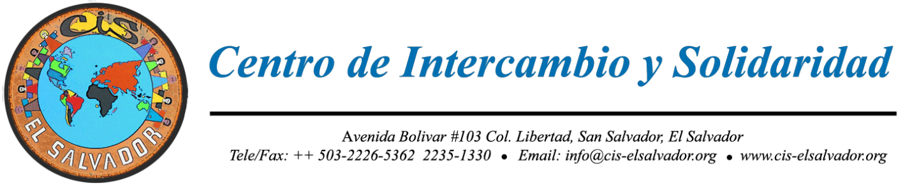

www.cis-elsalvador.org
Facebook: Centro de Intercambio y Solidaridad

CIS Delegation Orientation Packet
Updated January 2020

INDEX:

- Introduction and CIS Mission
- Logistics
- General Orientation
- Cultural Guidelines
- Financial and Material Aid Guidelines
- Communication Guidelines
- Group Guidelines
- Security Guidelines
- Health Care Guidelines
- Food Guidelines
- Misc. Guidelines
- Bibliography
- Individual Application Form
- Delegation Waver Form

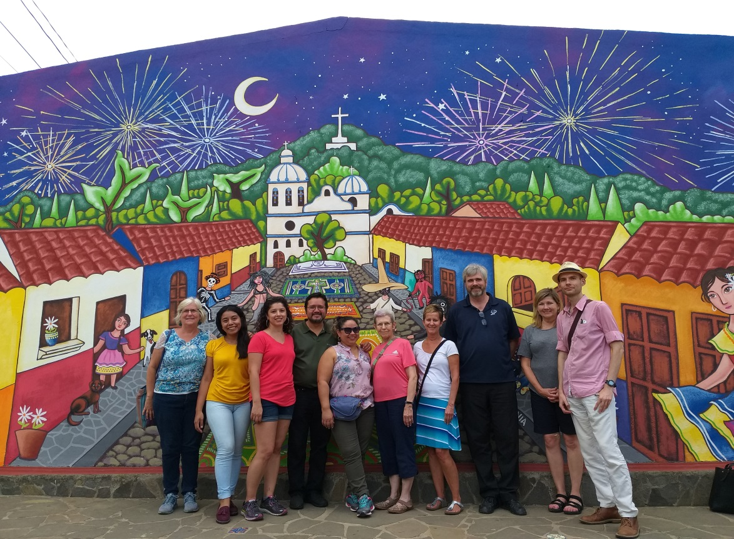

INTRODUCTION

CIS MISSION –The Mission of the CIS is to promote solidarity and exchange between the Salvadoran people and other peoples of the world. We work to support and promote a culture of solidarity, which includes accompaniment, respect for diversity, equitable relations and mutual support among human beings. The CIS also works to raise consciousness and to organize and mobilize towards social and economic justice and human dignity.
***
The CIS was founded in 1993 after the signing of the Peace Accords in El Salvador, ending the 12-year civil war. Solidarity groups from the U.S., Canada, and Europe came together with Salvadoran popular organizations to develop a center to promote people-to-people solidarity to continue to accompany the grassroots struggles for social and economic justice. The CIS’s philosophy is that long lasting social change comes from the grassroots. Our solidarity is aimed at giving a voice to the voiceless, the people most marginalized by neo-liberal economic policies. We promote non-violent means of social transformation through our educational and cultural exchanges and programs. We promote solidarity that foments self-determination and not dependency. We orient solidarity relations toward building awareness, participation, education and mobilization as tools for mutual respect and self-sufficiency.

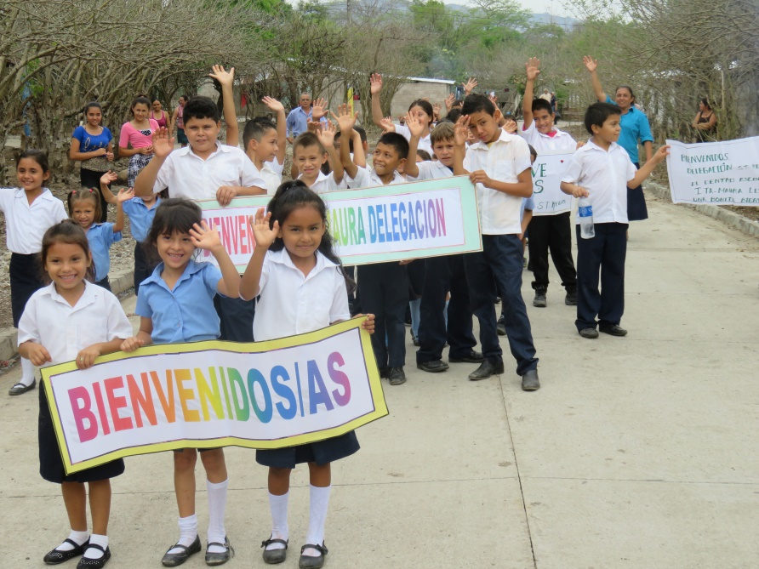

OBJECTIVES OF ORIENTATION PACKET:
1. Prepare you for a cross-cultural experience based on solidarity and mutual respect.
2. Prepare you for a healthy and safe visit.

LOGISTICS
Payment
- As of January 1st, 2001, the U.S. Dollar is the currency used in El Salvador. Nonetheless, many establishments will not accept bills over $20.
- Bring at least $100 in cash in denominations of $1, $5, $10 or $20 bills (MOST ESTABLISHMENTS WILL NOT ACCEPT BILLS HIGHER THAN $20; in the countryside it is hard to get change for bills higher than $5), set aside funds you may need to pay tourist visa upon entering El Salvador (US$12 - EXACT AMOUNT PREFERRED AS THEY DON’T ALWAYS HAVE CHANGE), and pay for your taxi to or from the airport (US$28) if you do not arrive at the time the delegation is arriving, and other miscellaneous expenses not included (souvenirs, soda, beer, internet use, laundry services, etc.)
- We recommend that visitors use a money belt to secure money and passport. (You need to carry your original passport at all times and especially when you leave the city, required by Salvadoran law).
- We recommend you bring the cash you anticipate needing. CIS accepts credit cards through PayPal and personal checks. ATM machines are available, but to not count on them working for out of country.

FEES AND PAYMENT
Fees during program dates indicated include:
*Housing in San Salvador and in the countryside if staying outside of San Salvador.
*Meals and purified water
*In Country Transportation (does not include plane ticket)
*CIS guide, translation, and program.

*Note - Additional housing before or after the program will be additional cost paid by the delegate, the CIS can make reservations and inform you of additional costs incurred.
*Delegation fees in general will be collected by your local delegation coordinator. Checks can be made in U.S. dollars to Los Olivos CIS / PO BOX 76 / Westmont, IL 60559-0076. Or they can be paid on-line where an additional 3% PayPal fee will be added: http://www.cis-elsalvador.org/index.php/en/payments
With payment Please indicate delegation name or dates of delegation

Documents Needed for Travel to El Salvador and How to Get Them
Passport:
You will need a valid passport (and photocopies in the event you lose your original - leave one copy at home with a friend) that will not expire within six months of the date of the trip. Getting a new passport usually takes about three weeks, longer near the holidays. Your nearest passport office is listed in the phone book, usually in the main Post Office or Federal Building
You need to carry your passport or a copy at all times while in El Salvador. Salvadoran officials can arrest you and hold you until you can get someone to bring your original passport.

Tourist Card and Visa:
Consult the Salvadoran Government’s web page: www.gobernacion.gob.sv to see if you need a visa, tourist card, consulted visa or nothing in order to enter El Salvador. Most visitors can enter on a tourist visa, purchased upon arrival at the airport in El Salvador for $10.

Entrance into the country
When you arrive by airplane, you will first go through immigration. You will need to declare an address of where you are staying. You can just put San Salvador. If they ask for an address, you can put Avenida Bolivar #103, Colonia Libertad, San Salvador. Reason for stay: TOURISM.

Then pick up your luggage and proceed to customs. Go to the line that says "No Declarar" (nothing to declare) with the form you filled out on the airplane. In this line, you will be asked to push a button, which will light up green or red. Green light - proceed out of the building. Red light - you will need to open up your bags to be searched. If your baggage includes boxes your baggage will automatically be searched. Generally, they will ask you to open up your bags and will just check around the sides. Should you be bringing donations like computers or other electronic devices, they should be identified for personal use.

After you exit the building, look for the CIS representative (if you are coming at scheduled date).

How to get to the CIS - LOCATED IN SAN SALVADOR
THE CIS WILL PICK YOU UP AND TAKE YOU TO THE AIRPORT IF YOU ARE TRAVELING ON THE OFFICIAL DELEGATION DATES

IF YOU GET LOST, OR ARE TRAVELING ON DIFFERENT DATES, HERE’S HOW TO GET TO CIS:
The CIS is located across the street from Instituto Ricaldone (Catholic school) and near the Sports Complex (Complejo Deportivo) of the University of El Salvador in San Salvador (FRENTE A LAS CANCHAS DE FUTBOL DEL INSTITUTO RICALDONE, ESQUINA). Most Salvadorans are accustomed to finding their way around by landmarks, and not street names and numbers.

CIS
Avenida Aguilares y Avenida Bolívar #103, Colonia Libertad
San Salvador, San Salvador,
El Salvador, Centro América
Telefax: ++503- 2226-5362 & 2235-1330x 104
e-mail: delegaciones@cis-elsalvador or info@cis-elsalvador.org.
In Case of an Emergency Call
In El Salvador:
Days: (011-503) 2226-5362 (CIS); 2235-1330
Evenings: (011-503) 2235-3478; (Leslie - CIS Director); 7709-3508 cell
Evelyn Portillo CIS Delegations Coordinator 6180-0080

For local personal transportation around San Salvador, CIS recommends the following taxi drivers.

Computers and phones:
Most Guest Houses in San Salvador and CIS have high speed wireless internet capabilities, but also have limited access to computers. We encourage delegates to bring laptops or tablets if you want to have daily access to internet. If a computer is available, delegates can check internet briefly at the CIS. There is Internet Access at all guest houses usually for a small fee and there are many inexpensive cyber cafes near the CIS.

Cell phones and chips are available for about $15 U.S. and come with minutes which are inexpensive for calling the U.S. and Canada. Additional minutes can be purchased.

What to Pack, What to Wear
Your appearance as a CIS delegation participant and representative of the international community in El Salvador is important. Dress to limit drawing attention to yourself (fancy with lots of jewelry attracts thieves, etc.). Women should be aware that not wearing a bra or wearing sheer dresses or skirts without a slip will likely draw unwanted attention. Spaghetti strap tops, halter tops, tight and/or short shorts are not to be worn at any time during the delegation. You need to dress comfortably. Clean, neat, casual clothes are fine. Don't expect to wear shorts, except for going to the beach or hiking. The weather will be warm (80-90 F) in the daytime. Women may be cooler in a skirt, but pants are fine. When you pack, think about what would be the easiest to wash by hand. In the evenings and the period from November to January, it gets cooler, so bring a lightweight jacket. Delegates should pack at least one formal suit/outfit for meetings with government ministers, embassy or other formal meetings. Make sure you bring a nice pair of dress shoes.

Good walking shoes are important. We recommend that everyone brings a shoulder bag to carry with you daily and for overnight trips. Backpacks are okay if they're clean and in good shape.

In general, bring the least luggage possible. Do not bring anything valuable that you could not stand to lose. We recommend that you pack a change of clothes and any medication in a carry-on bag in the event that your luggage arrives late. Liquids less than 6 ounces can be brought in carry-on bag in a clear zip lock bag/ larger bottles of liquid need to be in check on luggage, as required by the U.S. Government security guidelines. Here is a list of items that are necessary or optional to bring:

Necessary Optional
Money belt powered Gatorade / sports drinks for rehydration
Towel (if staying overnight in countryside) medicines- Tylenol, anti-diarrhea medicines.
Vital toiletries first aid kit
Vital clothing headache & cold remedies
Light sweater or jacket lock for suitcase
Family photos to share or show Credit card (do not rely on being able to use)
Handkerchief/bandanna personal checks (for emergency only)
Small backpack/tote for trips to countryside ear plugs
Hat camera
Sunscreen travel guide book
Bed sheet or light blanket if sleeping in countryside no-water hand wash/ handy-wipes
Bathing suit Lap top Computer
Small water bottle sunglasses
Travel clock with alarm Spanish grammar/verb book
Passport (& photo copy) travels iron
Umbrella and/or rain poncho May 1 – Nov. 1st. Non-perishable snack food
Flip flops for taking shower laundry soap
Notebooks, pens, pencils computer
Insect repellent driver’s license
Flashlight
Hand Sanitizers Spanish/English dictionary
Before taking photos or recording, be sure to ask permission. Respect the people you want to record.

GENERAL ORIENTATION

CIS was founded on the principal of solidarity. This is the basic orientation for the communities we work with and the delegations that visit. Solidarity, means to make common cause, mutual respect and reciprocity. Delegations or members should not come with the idea that we are coming to save the Salvadorans; as we usually receive much more than we can give to any community. Solidarity means more than charity in that it works to eradicate the roots of social and economic injustices and support self-determination; rather than just alleviating suffering for a short period. We need to ask ourselves constantly, how will this change people’s reality rather than doing what might feel good to us. We need to ask if our actions empower the people or submit them into becoming beggars or waiting for someone else to solve their problems.

We also need to listen to the community and not impose our own preconceptions. We can share ideas, but it is important to listen, as Salvadorans know their reality best. We do not want to be giving handouts or privileges to individuals in the community and create a culture of the people “liking us” to get something material out of the relationship. We want to work together in a real partnership. Otherwise, we may do more harm than good.

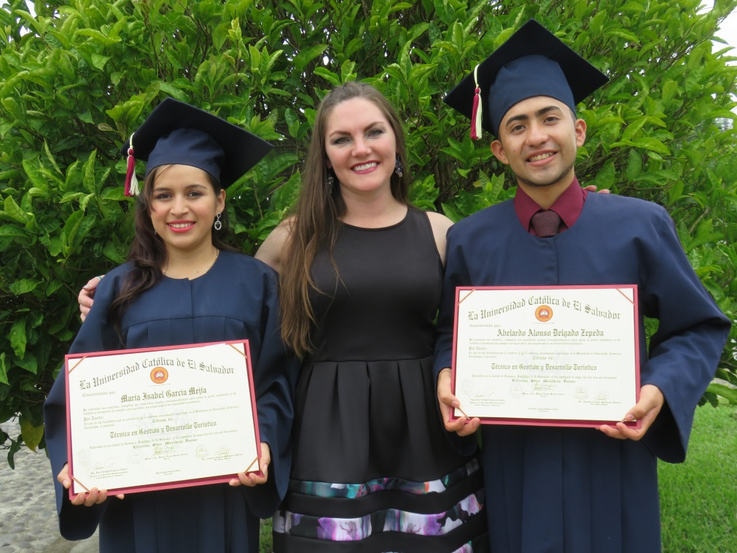

CIS delegations can be a life changing experience for many visitors and Salvadorans alike if we work on building a partnership based on solidarity and mutual respect. Foreigners are looked upon often with great respect, as being experts, and setting an example; this means that everything we do has an impact. We are not better than Salvadorans and we don’t have most of the answers. We need to take with much responsibility the fact that people will look up to us and not provide a bad example.

Everyone is required to attend an orientation meeting in El Salvador. Besides briefing you on the current situation in the country, cultural, security and health guidelines, and going over your itinerary, the orientation gives you an opportunity to review situations you might face on the trip and get to know others in the group.

You will meet wonderful and inspiring people, and you will share many good times as part of the program. You will hear stories of experiences from people who lived and struggled during the war and the current situation in El Salvador. Everyone who participates has a few experiences that really hit home. Sharing these experiences helps to convey the Salvadoran reality, which is one of the objectives of the program.

El Salvador can be uncomfortable at times. The weather is very hot and humid (air conditioning is rare and so rooms can be stuffy), and pollution is wide spread. Long walks in hot weather may be necessary. Other times, you will experience long rides down very bumpy and dusty roads. Sometimes there are limited food choices. At times, you may be without running water or electricity, and if you go to the countryside there may be nights where you'll sleep on the floor, with just a thin mattress or floor pad, and with very little privacy. These conditions can create some stress when combined with busy days, new food, and the work of learning a new language and living in a different culture. Bring a hat and drink adequate liquids throughout the day.

It is important that you be prepared physically and psychologically to deal with these conditions. If you feel uncertain, or have a history of recurring physical and/or psychological problems, talk with us before deciding to participate in the program. Discussing potential difficulties now can help; not doing so can create problems. Once in El Salvador, if you find you are having difficulties, don't keep that to yourself; talk to the CIS director or delegation coordinator, or your group coordinator.

The safety risks are more likely to take the form of common crime. In addition to common street robberies, gangs are present in El Salvador. You will probably not see a gang member during your stay though you may expect that since that is the most common media report about El Salvador. We want to clarify that the gangs started in the U.S. in Los Angeles. Many people fled their villages during the war or sent their sons to safety in the U.S. when during the Reagan Administration bombing of villages were carried out and all but ended the small village way of life in El Salvador. People fled to the city and then often to the U.S. In the U.S. the young people who fled were marginalized, with no family network and not speaking a common language. Many joined gangs out of boredom, self-defense – or wanting to belong to a family like structure. After the war, in the 1990s, U.S. Administrations began to deport the Salvadoran gang members back and they set up the gang structures in El Salvador. Today many Salvadorans are leaving the country for economic reasons or to flee gang violence. The gang violence is largely aimed at young Salvadoran men for being from a contrary gang or contrary gang territory. The migration of gangs has primarily been from North to South; not from South to North as is portrayed by the current administration or the media to justify anti-immigrant policies. About 70% members of Salvadoran gangs in the U.S. are U.S. citizens.

In 2019 The US State Department lowered the Alert Travel Warning from 3 to 2, the same designation as most European countries. This is due to an aggressive policy of the new presidential administration to confront crime and invest in areas that have been marginalized. The CIS always prioritizes security along with the communities we visit and have organized safe delegations since 1993.

None-the-less, internationals stand out because we are believed to be carrying lots of money and are often not as much on guard. The following guidelines are designed to protect you personally, and others you are with. The CIS cannot guarantee your safety, but if you assume these guidelines, risks will be kept to a minimum. They are based on years of experience. Following them will help you assimilate Salvadoran culture and function smoothly, with respect and solidarity and greatly reduce cultural mis-understandings

CULTURAL GUIDELINES
- Be sensitive to Salvadoran culture. Norms and standards in other countries are different. Many of our customs offend Salvadoran values. Delegation members should respect these differences and not be culturally arrogant. Be open and take suggestions from Salvadorans rather than imposing your views. Delegation members should, however, feel free to discuss issues and give their opinions.
- Be patient. The schedule of political and cultural events may change. El Salvador does not have the communications and transportation infrastructure you may be used to. Be flexible and expect delays and changes. And remember, the concept of time in El Salvador may be different from your own.
Out of
respect the delegation should always be on time.
- A neat appearance is important at all times. Salvadoran almost always wear clean and pressed clothes no matter how poor they are. It is respectful to Salvadoran culture to be neat and clean. Women should wear bras, knee length skirts and shorts, and slips if skirt is see-through or expect to be hassled by men or boys. Nice shorts can be worn to the countryside, beach, or hiking. You will not see Salvadorans wearing shorts for the most part and definitely not in the work place or formal settings. You are going to be representing the CIS and your home organization, and the international solidarity movement. You will show respect for the people you meet with by dressing neatly. Non-wrinkled, neat, casual summer clothing is fine. Whether your hair is long or short, it must be neat and clean at all times. Nose-rings are not common in El Salvador, so if you use one during your stay, expect stares. The same goes for tattoos (most people commonly associate them with gang members). If you have a tattoo, you might want to cover it up as much as possible when you are in the streets or in formal meetings. Do not wear Salvadoran political party t-shirts while in El Salvador; doing so could compromise the CIS.
- Cross-cultural romantic relationships are not recommended during the stay of your delegation because they can jeopardize the objectives and credibility of the delegation, group dynamics, and lead to serious mis-understanding due to different cultural norms.
- Machismo is part of Salvadoran culture. Your actions may be interpreted differently than they would be at home. For example, going out alone with someone will not be seen as getting to know each other (maybe to be friends); it will be seen as a date. As part of machismo, there is a double standard. Often, married Salvadoran men will approach women to start a relationship without mentioning that they are seriously involved with someone else. Instead of reflecting poorly on the man, this will reflect negatively on the woman. Delegates should make sure you engage women during your stay and not just focus your attention on men. Men are often given primary roles and are spokespersons, and the women are often relegated to tasks for the delegation such as cooking. We want to make sure we build up the women’s self-esteem and not just the men’s. Make sure you ask the women their opinion if you are in a meeting where only men are speaking.

FINANCIAL AND MATERIAL AID AND GIFTS GUIDELINES
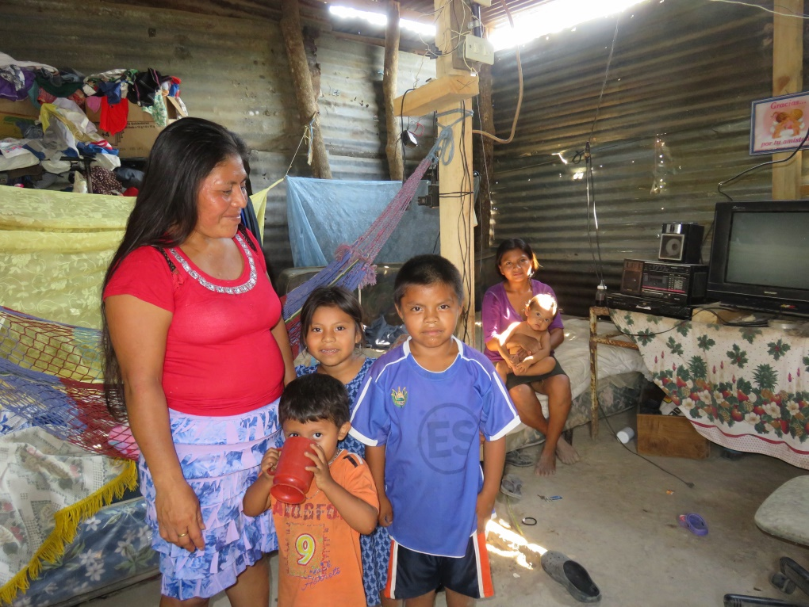

Donations brought by the group should be guided by the principal that it is to accompany social development in the community and strengthen people’s ability to help themselves; not building dependency or a culture of handouts. Human development and community organization are areas that can benefit the community for the long-term and support them in their own search for solutions to the problems they face.

The communities have the answer to their needs; we do not. Salvadorans will say yes to anything you offer because they do not want to reject any form of aid because of the huge necessities and they do not want to hurt your feelings. Try to listen and ask them what their priorities are as a community. If you wish to bring material donations, it should be at the request of the CIS OR a specific community or social organization.

The CIS asks you not to give any bi-lateral donations or commitments. This causes jealousy, undermines the community organization, and creates problems for the CIS and the community after you leave. All donations should be channeled through the CIS or the Board of the community or community organization (school, women’s group, water committee, scholarship committee, etc.). If individuals or the group want to respond to a need during your stay, CIS will need to discuss it with the community board of directors and make sure it happens in a responsible way.

The objective of the CIS is to build relationships of solidarity and mutual respect. We want to benefit the community development and not just do what makes us feel good. Your actions have a deep impact on the community. We do not want people hanging out with the delegation in hopes of getting a gift or personal benefit or build the image that the foreigners come with money or goods. This creates mistrust and accusations after the delegation leaves, often accusing community leaders of stealing imagined contributions.

- Financial donations for the community are better than material donations. The community can invest it in their priorities and not what you think should be their priorities. This should be worked out before your visit and generally channeled through the CIS, unless it is a small contribution for community organization or an immediate need.
- If you bring material donations, they should respond to concrete needs in the community. The community or organization (NGO, school, library, daycare, women’s group, pastoral group, youth, development council, etc.) should make a list of their priorities. These groups should be given enough time to ensure community participation. You should also ask for numbers. If a teacher needs 50 notebooks and you come with 10 pencils and 10 notebooks, he/she will have problems distributing them without causing problems.
- If a gift is for the community, it can be presented by the delegation. If the gift is for individuals, like clothing, notebooks, etc. this should be distributed by community leaders, teachers, or the given authorities and not the delegation. Handing out individual gifts in a group setting has led to fist fights, people getting in line twice, people who are sick being left out, and can be disorderly. It may also undercut the local leaders’ authority and promote a culture of handouts.
- In general, donations to individuals are strongly discouraged, unless it is a request from the community directive or other organized body. Everyone in the communities have needs greater than we can respond to. If we respond to one person’s request, others will have the same expectation with others in your group or the next delegation that comes. A donation given bi-laterally can cause jealousy and accusations of corruption of community leaders or others. If someone has a compelling request, you can bring it to the attention of the community leadership body for their advice. Sometimes, there is someone with an emergency medical need, a single mother with 12 children, or a child with a disability that the community would be happy to support if it had the means. Other times it is someone trying to take advantage of your good will. Or other times it is a legitimate need, but shared by many in the community---so it is best if the donation can go to a community fund, where the community organization can decide criteria, needs, and follow-up.
- If you want to give a gift that symbolizes your friendship to groups or individuals that host you, meet with you, or have you stay in their homes, the gift should be just that. It is nice to bring something symbolic that represents your culture such as a pin, key chains, pens, t-shirts with the name of your church, community, school, state, country, etc. as a demonstration of thanks and friendship. Bring photos of your family to show and/or give away are also appreciated.
- CIS recommends NOT bringing candies, piñatas or other handouts that promote assistencialism and can affect people´s health, since there is not adequate dental attention, a high level of diabetes, and creates more trash. In addition, piñatas can cause competition, fights and danger of hitting someone with a bat, where the biggest kids get more. Piñatas are commonly used as a form of submission, and are used by political parties, military and others to manipulate the population. If there is a special celebration between the community and the delegation, we recommend a lunch, cultural activity, games, a cake, sports event as alternatives.

CIS in conjunction with the communities requests contributions to support community organizing. We raise money on a continual basis for the following:

1. CLEAN WATER FUND. CIS provides families and communities with water filters, and training on hygiene, health, environment, clean water, and maintenance of filters. $75 will provide a family with training, a filter and buckets, and clean water for ten years. We required a minimum of 15 filters in a community to organize the trainings and distributions.
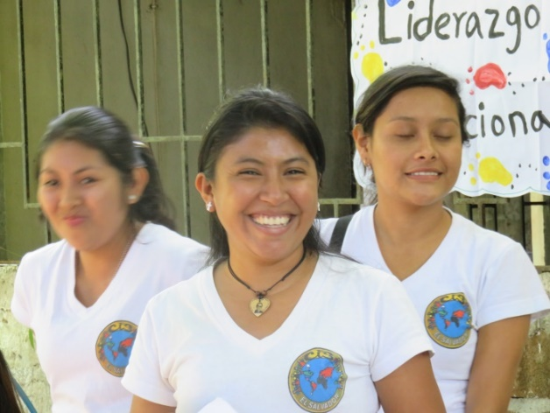
2. CIS SCHOLARSHIP FUND. Can be designated to a specific existing scholarship program, but cannot be designated for an individual. The CIS and the local community decide on who receives a scholarship based on criteria and participation. An individual designated scholarship can undermine the community organization and is prohibited if you seek a tax deduction in the U.S. Scholarship donations support high school (approx.. $300 year) and university scholarships ($1,000 approx. year) and go to fund annual scholarship retreat and organization of the program – (formation of scholarship committee, workshops, reports, visits, organization of volunteer project)

Tax-deductible donations can be made out to Los Olivos CIS and mailed to: Los Olivos CIS / PO BOX 76 / Westmont, IL 60559-0076. Please make a note if you would like to designate donation to a specific program.

Material Aid donations requested by CIS for educational and organizing work:
*Canon 40, 41 black and color ink jet cartridges.
*HP 972A PageWide Cartridge, black (F6T80AN)
* HP 972A PageWide Cartridge, cyan (L0R86AN)
*HP 972A PageWide Cartridge, yellow (L0R92AN)
*HP 972A PageWide Cartridge, magenta (L0R89AN)
*Magic Markers
*White board markers
*Pens.
*Paper Clips
*stick glue
*white out
*2 pocket folders - blue
* Name tags
*Colored paper – card stock, different shades.
*Color file folders
Community donations (general recommendation):
priority for communities with scholarship programs. Consult with CIS regarding a specific community’s priorities:
New lap top computers, with up to date programs: Core i5; 8GB Memory; 500gb Data Storage
Antennas to improve internet signal (available on amazon)
Memory USVs for scholarship students.
Printer and accessories
Power Point Projector
All types of art supplies for art therapy program
Stainless steel water bottles
Soccer balls
Soft Ball Equipment
Literature in Spanish for children and adults for Community Library, Day Care, or School.
CIS can develop a list upon request in consultation with the community or social organization if you request this in advance. Remember, no material donations are required for your visit.

COMMUNICATION WITH SALVADORAN COMMUNITY MEMBERS
In the age of social media, it is much easier to directly communicate with Salvadoran counterparts when you are back at home. We ask that this communication build a positive healthy relationship based on solidarity and mutual respect and not undermine the CIS or Community organizations. For that reason we ask the following.

- Do not offer bi-lateral material donations to friends you have made. In the same respect, do not entertain requests for bi-lateral donations. If someone has a compelling need that you wish to respond to, please notify the CIS or the community leaders to make sure it is a legitimate need and that the community supports it.
There is an extensive process by the community and CIS to select scholarship students. If there is someone who was not considered, the delegation can request that that person can be considered for the following year, but we cannot guarantee they will be placed. There is a process of criteria which includes economic need, participation and living in the community, desire to study, and a balanced inclusion of women, since they are often left out. Also, it depends on how many funds are available, since there are more requests than scholarships available.

2. Do not offer or entertain bi-lateral request for visas to the United States, Canada or elsewhere.
- If someone is in danger and you wish to help, please bring it to the attention of CIS or the community leadership to make sure it is a valid request and so that proper support can be given.
- If you have made a friend, there is no way you can guarantee a visa; although, Salvadorans will think you can just by the fact that you are from the U.S. or another country. Additionally, if a visa was granted you would be legally liable, and most Salvadoran approaching you, would be for migration purposes, even though they might not state this.
- If your group is hosting an exchange, CIS and the local community go through a process to select who would be the best representative (based on leadership, public speaking, personal history, commitment to community program, ability to get a visa). When people are hand-picked without a process, they have in some occasions felt entitled and see it more as a personal achievement, rather than a combined community/personal achievement and representation.

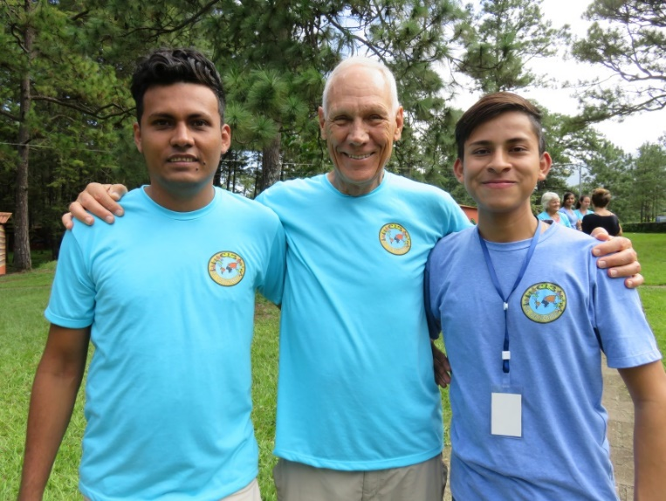

GROUP GUIDELINES
- Respect the other delegation members. Sexist, homophobic, racist, and other oppressive attitudes are not acceptable and will not be tolerated.
- Evaluate everything you do and say in terms of its effect on others. Avoid actions that attract attention. Think before you act or speak.
- Stay with your group when group activities are planned. Please do not leave the group without talking to the coordinator first. Also, if you will be coming home late, let the delegation coordinator know what time, and remember that Salvadoran streets are empty after about 8 p.m. If the coordinator says you are in a situation where the security risk is serious, you must follow his or her directions and ask questions later.
- Respect the decisions of the CIS and Salvadoran hosts and your group coordinator. They are responsible for your well-being and the program. If you strongly disagree with a decision, raise your concerns with a member of the CIS staff.

- Delegation members are expected to attend all group meetings and activities, unless have you advised the coordinator in advance. If you do not feel well or are tired, you may want to skip an event to rest. You may also want free time to do something else. However, if meetings and activities are tightly scheduled, the group may not have the time to come back for you, making it your responsibility to arrange for transportation to the next event.

SECURITY/SAFETY GUIDELINES
- Be careful crossing the street. The law of the fittest often prevails in the streets, and some buses and cars will not stop for pedestrians. Make sure to look both ways, and then look again. Traffic rules may not be the same as those to which you are accustomed.
- Stay alert. Pay attention to everything going on around you -- in the airport, restaurants, on the street, in busses, offices, at the beach. You don't need to walk around paranoid and constantly looking over your shoulder, but you need to be aware. If you look vulnerable, you are more likely to be robbed.
- Do not carry large amounts of money with you unless it is necessary. Do not count money or pull out large amounts of money in public; even if there is a security guard nearby, thieves will follow you to where you are out of security guard’s sight. Do not wear jewelry that might be attractive to thieves, expose cameras, etc. What you carry could be stolen. Most travelers decide not to wear wristwatches in public; they are very frequently stolen. If you are robbed - do not argue; give the thieves what they ask for. Leave things you cannot bear to part with at home.
- It is prohibited by Salvadoran law for foreigners to engage in politics. Doing so can put yourself or the delegation at risk of being deported. It is important not to actively support one or another political party. It is also important not to publicly criticize Salvadoran Government policies or members.
- Do not tell people you do not know where you are staying or about the CIS. You can make general statements without being rude; but do not give details such as names or places that could be useful for robberies, extortion, or other.
- Excessive drinking and use of non-medical drugs can reflect badly on you and on the CIS, and can result in an error of judgment and security risk. Drugs are both illegal and generally not accepted in El Salvador. While participating in CIS programs, drinking is prohibited during visits to the countryside for cultural reasons, both because of the high levels of alcoholism and because drinking in public gives a negative impression. In the countryside, two beers represent a day’s wages. For example, a male head of household may spend the day’s wages on alcohol and the family is left with nothing to eat. People look up to foreigners and seeing a foreigner drinking will be used by locals to justify their actions. In the city, please act responsibly.
- Going to the beach. Beaches in El Salvador are beautiful with warm water and can be enjoyed if given proper respect. The only incidents of members of international delegations dying in El Salvador have been by drowning. El Salvador has strong rip tides that can drag a person out and knock you out if you try to swim to shore and against the current. The CIS asks that people do not go into the ocean above their waists to prevent being pulled out by the tide. If you feel the ocean pulling you out more than bringing you in, it is time to come in. Do not drink alcohol and then go in the ocean. If you find a member of your group has been pulled out, it is important to remember the following: Do not go in after the person or you will be pulled out too; find a qualified Salvadoran who knows the tides to go out after them. If you find yourself caught in the tide, do not scream for help or panic, your energy will wear out faster. Swim parallel to the shore or out with the current until you can find a place to swim in where the current is not so strong. If you swim into the current that is pulling you out, you will be running against a tread mill and run out of energy quickly and more likely drown. Women should not walk alone on the beach and you should not leave sandals or other things on the shore unprotected or they will get stolen.
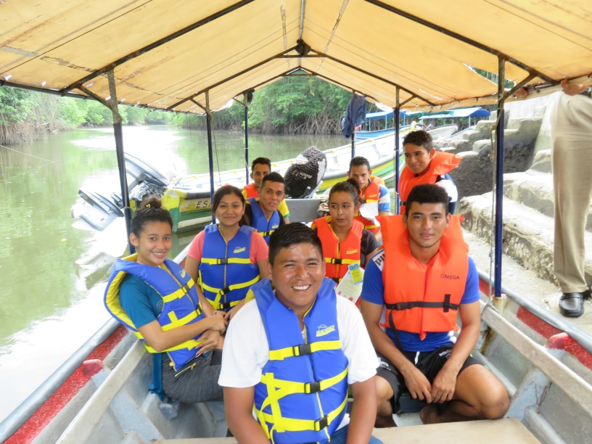

- Earthquakes. In the event of an earthquake, you should not panic. Buildings do not fall down until rocked for some time—so if you are alert and quick you can escape heavy things falling on you. Additionally, most buildings are one floor in El Salvador. The majority of deaths in earthquakes are caused by landslides or where elderly and babies who could not get out of harm’s way. You can safely stand under a doorframe, desk or bed, if indoors. If you have access to a patio, garage, or other area where heavy things will not fall on you, move immediately to a safer place. Beware of going out into the street in the city, as electrical lines falling can be more dangerous than a roof tile.

HEALTH CARE GUIDELINES
Most illnesses you are susceptible to in El Salvador are related to contaminated water, mosquitos, and the hot tropical sun. So you should prepare accordingly. Please consult your physician for additional recommendations.

No shots are legally required for travel to El Salvador. However, the Center for Disease Control and the World Health Organization recommend that you be up to date on your diphtheria-tetanus and polio inoculations. Some doctors advise hepatitis A vaccine or a gamma globulin shot for protection against hepatitis A, and oral typhoid vaccine, which are easily contracted and relatively serious. Please speak with your doctor about which vaccines she or he recommends.

The best prevention against malaria (which has been virtually wiped out in El Salvador), dengue fever, zika and chikungunya (more common) is mosquito repellent. Bring enough to get you through your stay. If you get a fever and suspect it may be dengue, zika or chikungunya, do not take aspirin or ibuprofen, which can cause blood thinning and hemorrhaging. Only take acetaminophen or Tylenol. The mosquitos that spread these diseases only bite during the daytime. The pesky mosquitos that buzz in your ear at night, do not. Some people wear socks and long pants to avoid being bitten in the daytime. Mosquitos are attracted to darkness, so wearing white or light colored clothing also helps repel mosquitos.

Visitors to El Salvador frequently suffer from diarrhea, and sometimes mild stomach cramps caused by intestinal microorganisms their bodies are not accustomed to. For minor cases, Pepto-Bismol is recommended; Bactrim and Lomotil (you need a prescription) alleviate more severe cases. Acidophilus pills (available at health food stores) or garlic have been recommended by some people, who take them daily as a preventative measure. You may want to take some or all of the above with you. Garlic can easily be bought in any Salvadoran market. If your case is severe, you may have parasites or amoebas and should consult a doctor. We can direct you to a nearby clinic - just ask the coordinator.

The sun in the tropics is stronger than what you might be used to. For trips to the beach, everyone should use sun block. Hats and sunglasses are recommended if one will be riding in the back of a truck or walking in the sun. Always carry a bottle of water to avoid dehydration, and because purified water may not be available.

If you have a bad headache, chance are you are dehydrated, and drinking water alone will not recuperate your hydration. You will need to recuperate your electrolytes by drinking a rehydration serum (available in packets at most Salvadoran pharmacies or Pedialyte (more expensive), lemonade with a little salt in it, or sports drinks.
The most important thing is not to get dehydrated- drink water, sports drinks, juices, etc.

FOOD GUIDELINES
The best prevention of stomach ailments are a careful diet and hygiene. Hepatitis, cholera, amoebas, parasites, and diarrhea often come from contaminated food bought on the street or in small stand, from drinking contaminated water, or from flies landing on your food. A few basic guidelines are:

- Drink only water that is bottled and specifically labeled as purified water ("Agua Cristal"). Avoid ice unless you know it is made from purified water.
- Make sure fruit juice "frescos" do not have water or ice added, unless it's made from purified water.
- Eat vegetables or fruit only if cooked (or otherwise disinfected), or if you peel them yourself. Anything washed in water can carry bacteria.
- Don't eat any raw or under-cooked fish or shellfish, the most common carriers of cholera.
- Avoid salsa or salads that sit in jars or on tables all day. Pupusas, Salvadoran’s favorite food is served with tomato sauce and slaw. You can put the tomato sauce on the pupusas as it is cooked and prepared. However, the delicious slaw is usually raw cabbage and should be avoided in public restaurants. If you host or guest house has prepared the slaw special by cooking it, you can eat it.
- Don't eat foods that have been sitting out for a period of time
- Never eat food bought on the street.
- Wash your hands regularly and always before eating. Bring hand towelettes or sanitizing gels in case there is not a place to wash your hands.
- Do not allow flies to land on food.
Note on Upset Stomachs
Almost all travelers who are not accustomed to the food or water in El Salvador will at some point get sick to their stomachs. Usually, we recommend that you wait a few days before you worry about going to the doctor as often stomach problems will go away on their own or with home remedies after 3 to 5 days. The following are a few recommendations we have compiled to ease your symptoms:
- If you are having diarrhea, make sure to keep hydrated. Drink a lot of water and rehydration drinks.
- Coconut water is beneficial for upset stomachs, as it has a mild flavor and some nutritive value, and is a good source of liquid. (Note: if you are buying it on the street, be careful of utensils and water that are sitting out in the open and look unclean)
- Eat a clove of garlic every day for 14 days - raw, cutting out the core (which can irritate your stomach), and before/with breakfast or before you go to bed works best. If your stomach doesn’t feel even slightly better in 4 days, see a doctor or go to a clinic. Garlic is a natural anti-biotic and can get rid of bacterial infections without having to take harsher medicines.

MISCELLANEOUS GUIDELINES
- Do not throw toilet paper in toilets, but in waste paper baskets beside the toilet. The Salvadoran plumbing system is not modern. Don't always expect there to be running water; most neighborhoods are without water for some period of time every day. The pipes leading out from toilets are smaller in diameter than in other countries, and are easily plugged up. Put toilet paper and other foreign objects in the wastebasket, not in the toilet. If there isn’t running water, you can flush the toilet by dumping a bucket of water into the toilet bowl.
- Latrines. Many toilets in the countryside are latrines. If they are built a few steps off the ground, they are most likely dry composting latrines, which are environmentally friendly, if used correctly. They are anatomically built to separate liquid from solid waste, so the waste can be used for fertilizer afterward. You can throw toilet paper in the solid waste side and there are generally ashes or lye that you can throw in afterwards to cut the odor. Make sure ONLY LIQUID WASTE goes in the liquid side or you will clog the latrine and make a very difficult and messy job for the family.
- Washing up & Showers. Running water is not guaranteed in the city or the countryside. Usually, only cold water is available. Homes around the country generally have a big sink (pila) filled with water. You can scoop clean water out with a bowl (huacal) to wash up, wash clothes, or take water to flush the toilet. The water in the pila should remain clean—don’t throw your dirty clothes into it or wash your hands under the faucet with water falling into the clean water supply. In the city, there are showers available and water often only runs in the morning. Generally there is a barrel of water available and a bowl (huacal) to sponge bath and rinse off. In the countryside, bathing areas in homes are often public; you may want to take a swimsuit or bath at night for more privacy.
- Heated showers. Some rooms in some guest houses now have electric water heaters attached to the shower. You must turn on the fuse switch and then the switch on the shower head. These heat up immediately and should only be on during use. It is important to turn off the fuse box immediately afterward too, as they can be a fire hazard if left on. If there is very low water pressure, do not use the heater. If you smell burning plastic or see large amounts of steam emanating from the heater, turn off the heater and the fuse box immediately.
- Many vegetarians and vegans and persons with lactose or gluten intolerance have participated in our programs with few problems; however, in some places your meals will have little variety. . People with special dietary needs need to let the CIS know in advance so we can plan your meals accordingly and you may want to bring snacks to supplement meals.
- Please bring a photocopy of your passport - if you lose your original this will be a great help. You must have your passport on you at all times or you can be arrested. You will need your original passport for bank transactions and to enter your Embassy.
- You may want to learn how to introduce yourself in Spanish, including where you are from, what you do (your coordinator can help you with pronunciation):
My name is_________________________; Me llamo _______________________________
I am from___________________________; Soy de (ciudad y estado y país)
I am a/ I am studying__________________; Soy ____________________; Estudio ____________

Thank you for your Solidarity and building a better world based on dignity, mutual respect, social and economic justice!
BIBLIOGRAPHY
Suggested Readings

* The Beast: Riding the Rails and Dodging the Narcos on the Migrant Trails, Oscar Martinez, 2014.

*"El Salvador, A Negotiated Revolution" by Hemisphere Initiatives; 130 Prospect Street, Cambridge, MA, 1993.

* El Salvador: A Decade of War; ed. Anjali Sundaram and George Gelber. New York, NY: Monthly Review Press. 1990.

* El Salvador - 2nd Edition; Tommie Sue Montgomery; West View Press, 1995

* El Salvador On Your Own Travel Guide. On Your Own Publications.

*Gangsters Without Borders. T.W. Ward, Oxford University Press, 2013

* From Grandmother to Granddaughter: Salvadoran Women's Stories; Michael Gorkin, Marta Pineda, and Gloria Leal. Berkeley, CA: University of California Press, 2000.

* Inside El Salvador: The Essential Guide to Its Politics, Economy, Society, and Environment; Kevin Murray & Tom Barry. Albuquerque, New Mexico: The Resource Center Press, 1995.

* Lonely Planet: Central America on a Shoestring.

* The Massacre at El Mozote: A Parable of the Cold War, Mark Danner. Vintage Books, 1994.

* Oscar Romero: Memories in Mosaic; Maria López Vigil, EPICA, 1993

* Women in War: The Micro-processes of Mobilization in El Salvador, Jocelyn Viterna, New York, NY: Oxford University Press; 2013

*When Dogs Ate Candles; Bill Hutchinson, 1998.

Videos
Monsenor, The Last Journey of Oscar Romero. Notre Dame University 2010.
Romero. Starring Raúl Julia. Vidmark Entertainment video. 105 minutes
School of the Assassins. Narrated by Susan Sarandon. Maryknoll World Productions.
El Salvador: Not for Sale! Produced by CISPES, (212) 229-1290, www.cispes.org 30 minutes
Zoned for Slavery: The Child Behind the Label. National Labor Committee, NY (212) 242-0700. 23 minutes

Web Sites

Newspapers and Alternative News
Diario CoLatino: www.diariocolatino.com
El Diario de Hoy: www.elsalvador.com
La Prensa Gráfica: www.laprensa.com
National Catholic Reporter: www.natcath.com
NACLA: www.nacla.org

Organizations
CIS: www.cis-elsalvador.org
Chicago Religious Leadership Network on Latin America: www.crln.org
Resource Center of the Americas: www.america.org
Latin American Working Group: www.lawg.org
Rainbow of Hope for Children: http://www.rainbowofhopeforchildren.ca
School of the Americas Watch: www.soaw.org

PLEASE E-MAIL TO CIS: delegaciones@cis-elsalvador.org so we can better organizer your stay.
APPLICATION FOR DELEGATION MEMBER:

Name: (legal as in passport)____________________________________________________________

Passport Number and expiration date:_____________________________________________________

Name you like to be called by:___________________________________________________________

Gender:_____________________________________________________________________________

Address______________________________________________________________________________

State/Dept, Province___________________________________________________________________

Postal Code/ Country___________________________________________________________________

Telephone___________________________________________________________________________

e-mail________________________________________________________________________________

Name of Delegation/Church/School/ Etc.___________________________________________________

Date of Birth / age:____________________________________________________________________

Profession/area of study:_________________________________________________________________

Spanish Level (circle one) ZERO -- BEGINNER—INTERMEDIATE---- ADVANCED--- FLUENT

Have you been to El Salvador before?_____________________________

(if yes) When? With whom/ /How many times_______________________________________________

____________________________________________________________________________________

Special Dietary needs: (vegan, vegetarian, diabetic, allergies, gluten free, lactose free, eat everything)___________________________________

Special health conditions we should be aware of?___________________________________________

Why do you want to participate in this program?_____________________________________________

Is there anything special you would like to learn about or see while in El Salvador?________________

Emergency Contact Info: Name, phone number, e-mail, messenger or other ways to contact in a timely manner:____________________________________________________________________________

Delegation Participant WAIVER OF LIABILITY/ YOU CAN E-MAIL US THIS: delegaciones@cis-elsalvdaor.org. You can also bring printed copy and turn in when you arrive.

I, _________________, voluntarily join the Centro de Intercambio y Solidaridad in El Salvador for _________________________________ (dates of session). In that capacity, I will be traveling to El Salvador and visiting various Salvadoran groups and touring the country.

I am participating in this program because I want to support human rights and democracy for the people of El Salvador and gain a better understanding of the situation in El Salvador. I recognize and assume the risks of travel to and within El Salvador, a country with extreme poverty and often very difficult conditions.

On behalf of myself, my family, heirs, representatives, executors, administrators and all other persons making any claim by any reason of any relationship to me, I hereby release and hold harmless the Centro de Intercambio y Solidaridad, and any of their affiliates, subdivisions, officers, directors, teachers, employees, advisors, agents and representatives from any claims, damages, costs, including attorney fees, or other liabilities resulting from personal injury, property damage, or other losses of any kind in any way connected with participation in this program.

I have carefully reviewed the foregoing and this form in its entirety, and by signing below agree to its terms with full understanding of its meaning and effect. I have also read the orientation packet and program guidelines. I understand and agree to abide by them for the duration of my participation in the program.

Signature: ______________________________________ Date: _____________________________
Address: _____________________________________________________________________________
Phone numbers W ( ) H ( )

******************************************************************************************

IN CASE OF AN EMERGENCY, CONTACT:
Name: ______________________________________________________________
Relation to you: ____________________________________________________
Phone numbers: Daytime (___) ______________ Evening (___) _____________
Email: _______________________________________________________________
Messenger, Facebook, WhatsApp, or other forms of contact: ______________________________

* Please note: Sponsoring organizations take no responsibility for your medical care or the availability of medical services during your travel; however we can take you to a clinic or hospital. We are not responsible for any health problems that may arise in El Salvador.

